**COMP 3059 – Capstone Project I**

**Software Requirements Analysis and Design Assignment**

**1.0 Introduction**

This document contains information that would give an overview and specific information about ParkVRO project

## Purpose

The purpose of forming the team is intended to facilitate the development of an application for parking cars. Our app aims to increase parking availability in large cities. Through the connection between individual parking owners and drivers, we will be able to reduce the parking shortage.

## Scope

* Place a reservation for parking
* In app user feedback
* Chat box
* Lease a parking spot
* Pay for parking spot
* Create account
* Geolocation integration for parking spots

# System Overview

## Project Perspective

ParkVRO is a self containing project that does not build on top of any existing application or codebase. However I will be integrated with other systems such as Google “FireBase” to allow users to “Login with Google” and simplify creation of new accounts.

## System Context

Result of this project will be a mobile application as well as a website that would allow users to find nearest available parking spots, pay for them and use them. I will decrease the time spent by each user trying to find a parking spot during the “Rush Hour”.

## General Constraints

Main constraint of our application is that “It is only useful if a lot of people are using it”. Our business model will be similar to those of Uber or Airbnb. That means that we will have to do everything we can in the initial phase of the project to grow our number of users. Most of this will be a problem of the marketing department, but some constraints can be solved by software as well. For example, we will make Creation of new accounts as easy as 2 clicks, users will be able to create their account using google auth services and start using our application right away. Also since our business model requires a huge user base to be profitable, we would use AWS. AWS services will only charge for the amount of resources that we are great for scalability. Also we would have to design our database and each layer of application (FrontEnd, BackEnd, DataBase) in a way to allow easy integration of new features.

## Assumptions and Dependencies

As stated earlier we assume rapid growth and capture of huge market share thanks to absence of competitors. Also, for our project to be successful it’s as important to gain momentum as to continue growing.

## 3.0 Functional Requirements

## 3.1 Use Case

### 

**3.3 Data Modelling and Analysis**

Normalized Data Model Diagram 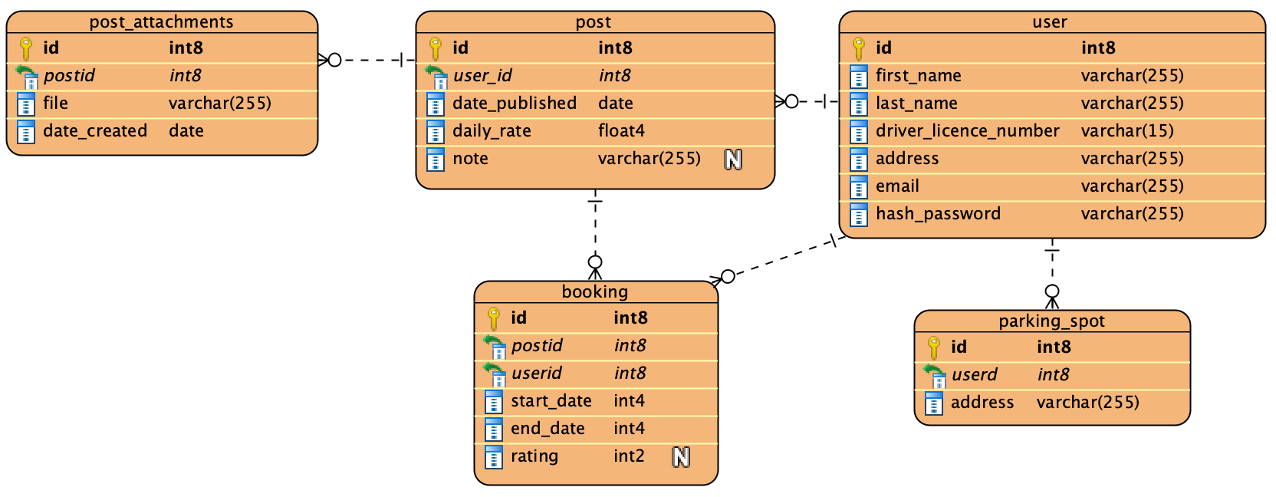

Activity Diagrams 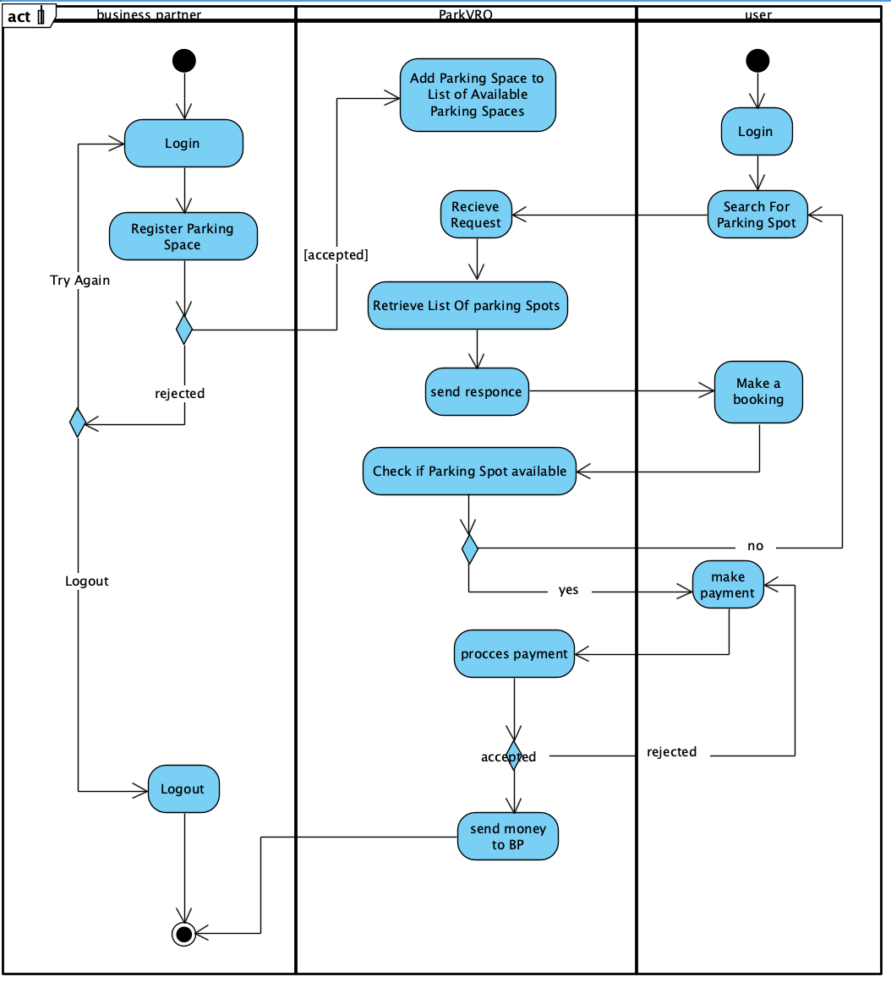

Sequence Diagrams

Posting Parking Spot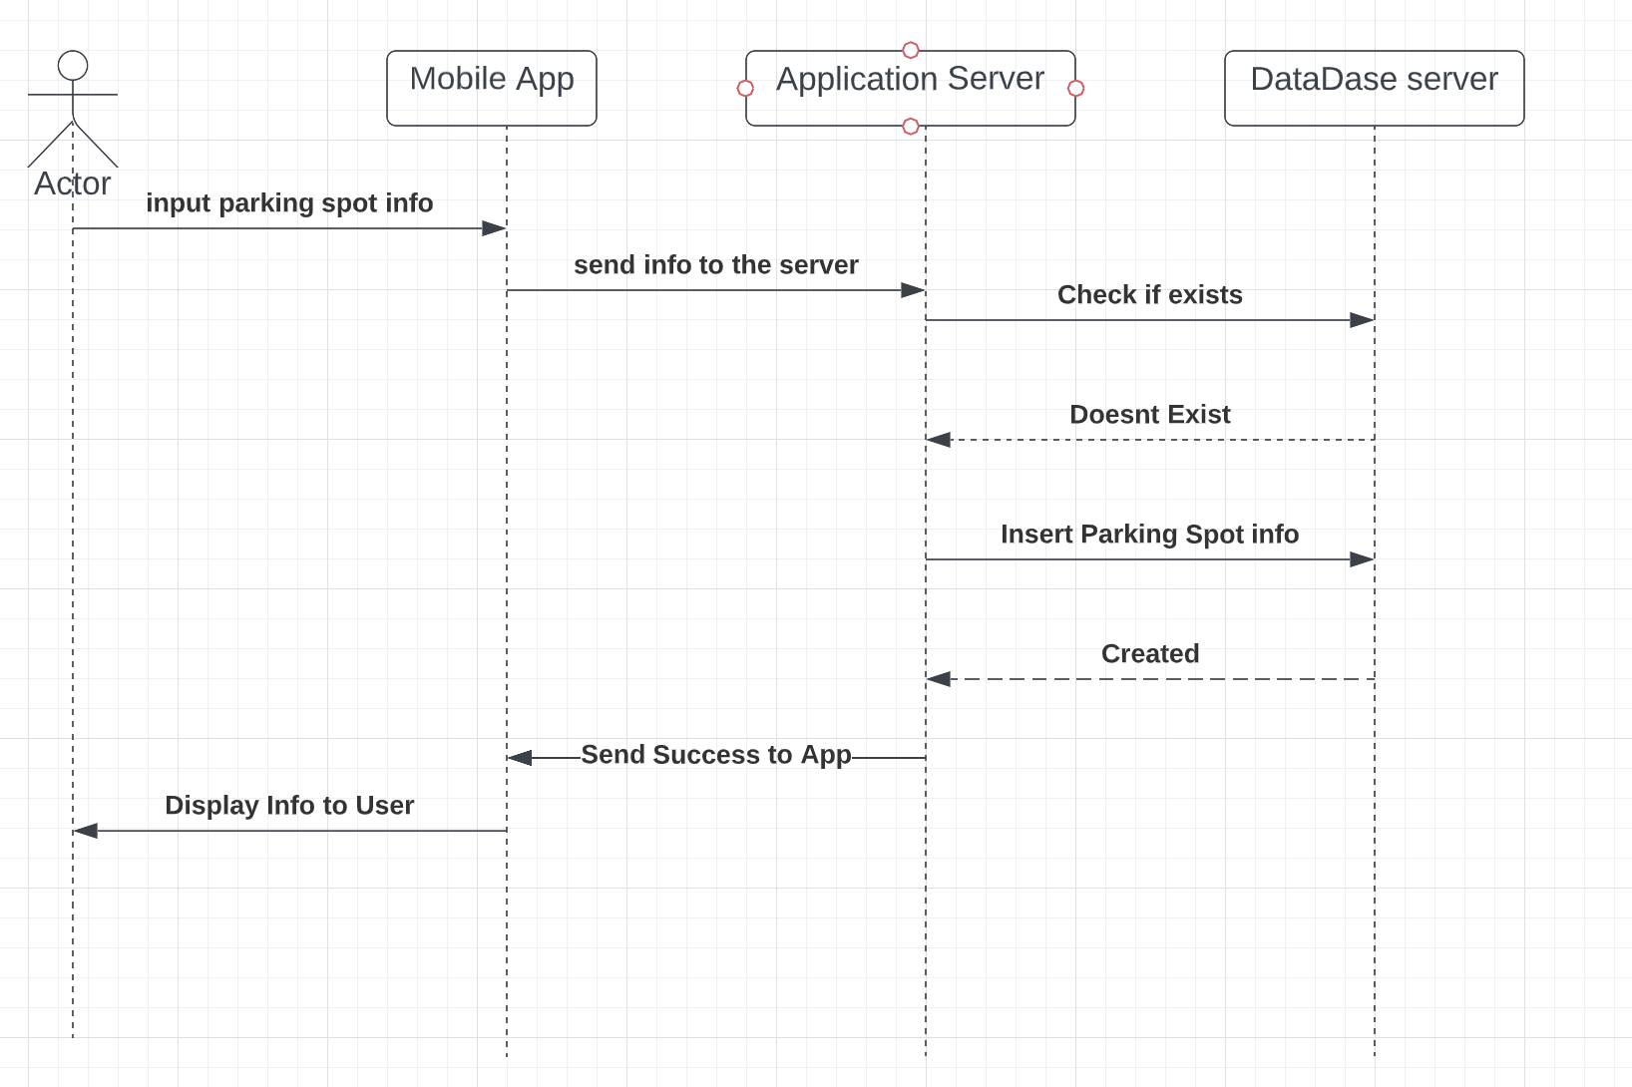

Booking parking Spot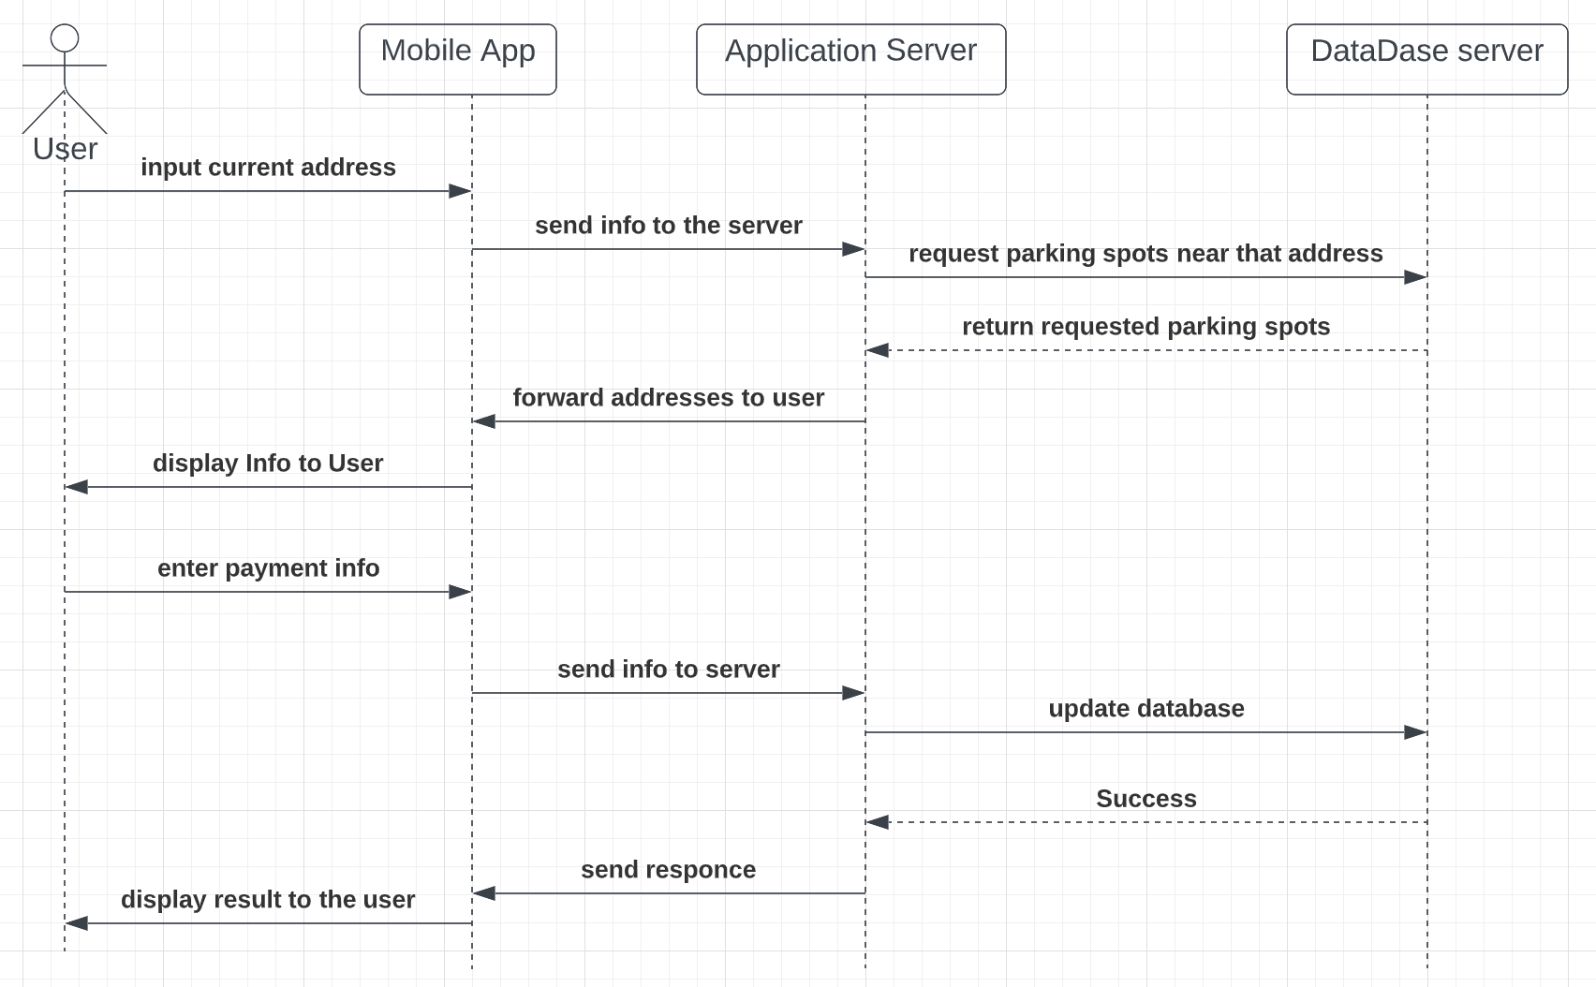

UML Class Diagram

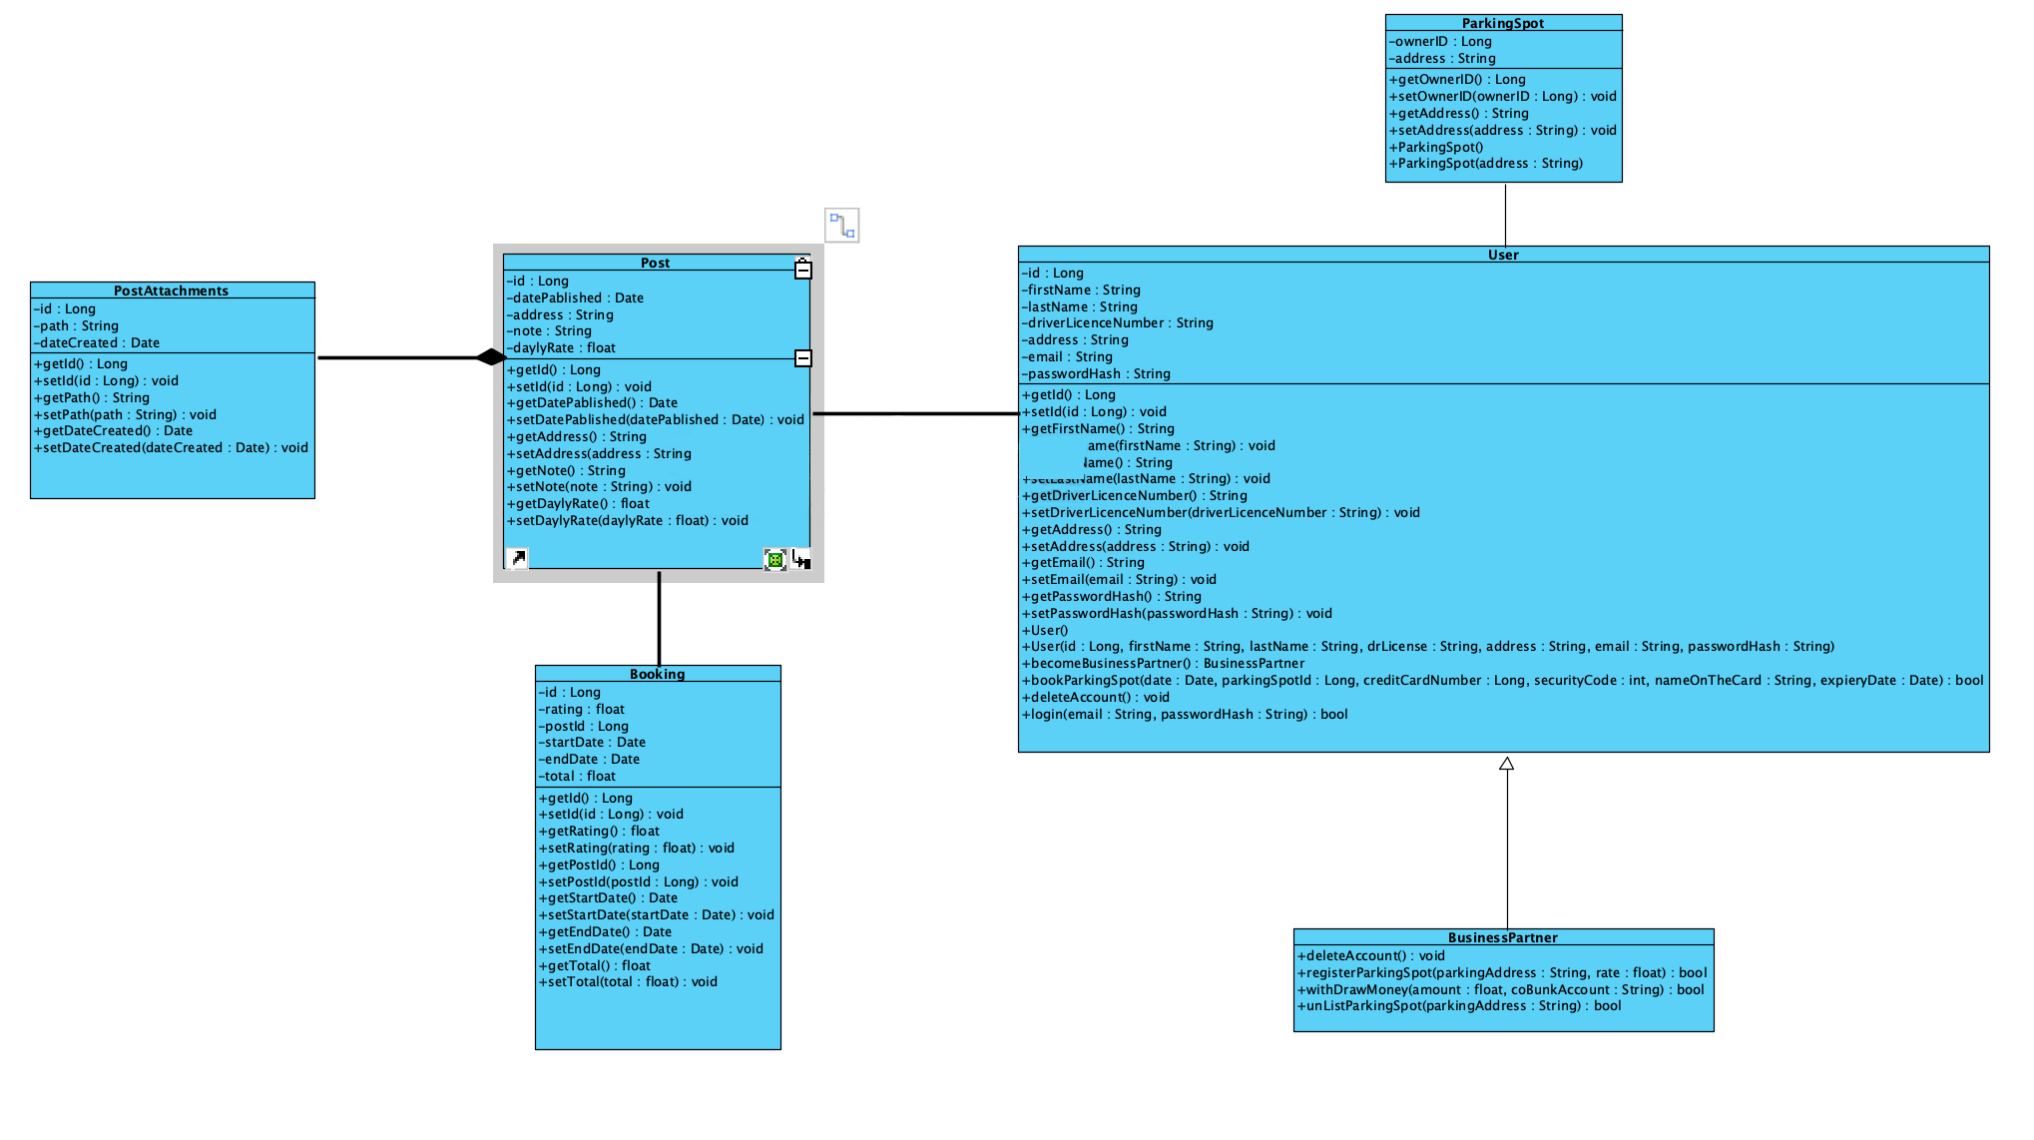

**3.4 Process Modelling**

* Data Flow Diagram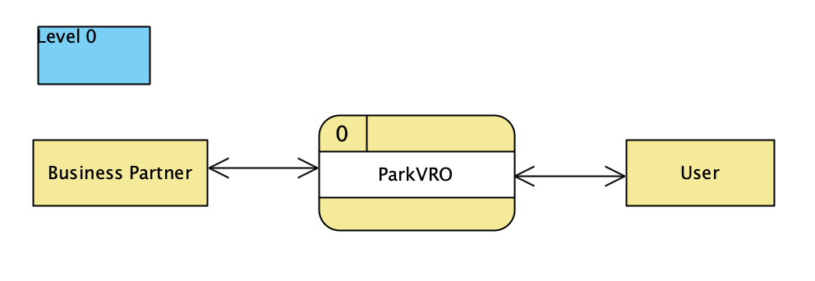

## 

## 

## 

## 

## 

## 

## 

## 

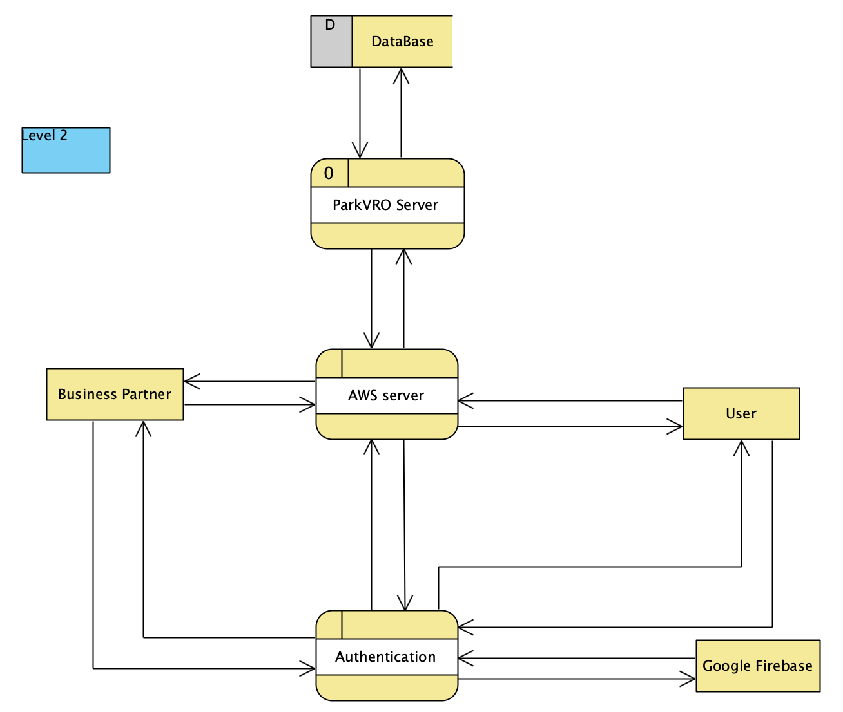

## 

## 4.0 Non-Functional Requirements

* Server should be DDoS resistant
* Server should be able to handle
* Application should be SQL injection resistant
* 90% of requests should be processed in less then a second

## 

## 5.0 Logical Database Requirements

All requirements for the database are shown in figure 3.3 . Other requirements like scalability, backup and deployment will be provided with AWS.

## 

**7.0 Approval**

The signatures below indicate their approval of the contents of this document.

| Project Role | Name | Signature | Date |
| --- | --- | --- | --- |
| Developer | Ostap Sulyk | O.S. | 11.03.2022 |
| Developer | Rauf Anata | R.A. | 11.03.2022 |
| Manager | Veronika Ushynska | V.U. | 11.03.2022 |